**INTERNET AND WEB PROGRAMMING**

**LAB WORKSHEET**

NAME : BHRAMI.R.R

ROLL NUMBER:18BCS056

DATE : 05.03.2021

**EXPERIMENT : 1**

**AIM :**

TO DESIGN A WEBPAGE CONTAINING RESUME USING HTML.

**PROCEDURE :**

1. FIRST , WRITE THE CODE USING HTML IN NOTEPAD.
2. SAVE IT AS .html FILE .
3. RUN THE CODE ON A BROWSER

**CODE:**

<div id="header"></div>   
<div class="left"></div>   
<div class="stuff">   
  <br><br>   
<h1>Resume</h1>   
<h2>Bhrami-18BCS056</h2>   
<hr />   
<br>   
<b>   
<p class="head">Interests</p>   
</b>   
<ul>   
  <li>Drawing</li>   
  <li>Reading</li>   
  <li>Gardening</li>   
  <li>Design</li>   
  <li>Programming</li>   
  <li>Computer Science</li>   
</ul>   
<b>   
<p class="head">Skills</p>   
</b>   
<ul>   
  <li>Web Design with HTML & CSS</li>   
  <li>Web Development</li>   
  <li>Data Analyst</li>   
</ul>   
<b>   
   
<p class="head">Education</p>   
</b>   
<ul>   
   
    <li>10th - SRV Hi-Tech</li>   
    <li>12th - SRV Hi-Tech</li>   
    <li>Computer science and engineering - kumaraguru college of technology</li>   
</ul>   
   
  <b>   
   
    <p class="head">Certifications</p>   
  </b>   
  <ul>   
   
    <li>Social Media Advertising</li>   
    <li>Learn Android Application Development</li>   
    <li>Managing an Agile Team</li>   
    <li>Mongodb basics</li>   
    <li>Database Management System</li>   
  </ul>   
  <b>   
   
<p class="head">Experience</p>   
</b>   
<ul>   
  <li>currently studying</li>   
</ul>   
<b>   
<p class="head">Extracurriculars</p>   
</b>   
<ul>   
  <li>agam( yoga club)</li>   
   
     
</ul>

**OUTPUT:**

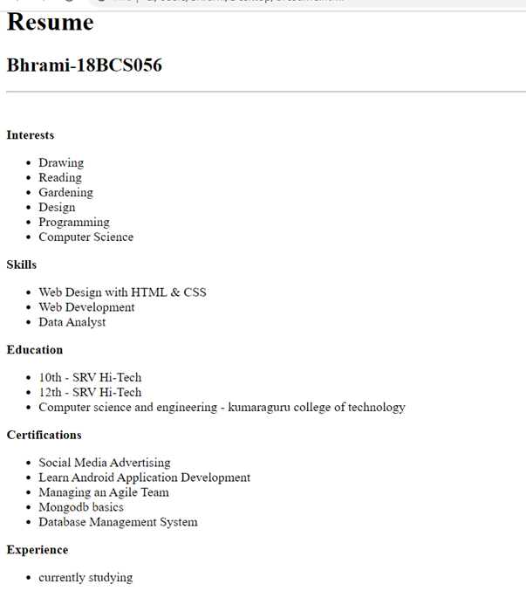

**RESULT :**

A WEB PAGE CONTAINING RESUME WAS CREATED USING HTML 5 CODE.